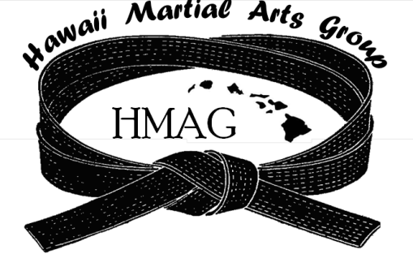
The Hawaii Martial Arts Group
http://www.hawaiimartialartsgroup.com
“Providing Exceptional Competitive Events
With Integrity, Fairness and Fellowship”

The 6th Annual Hawaii
Open Martial Arts Tournament

All Styles Welcome
Kata  Kumite  Weapons  Team Kata
Date: Saturday June 13, 2015
Time: 8:30 am to 5:00 pm
Where: Manoa Recreation Center
Manoa Valley District Park, 2721 Kaaipu Ave, Honolulu, HI 96822

Pre-Register by June 6, 2015
$15.00 per Individual Event

*NO Walk-ins Accepted*

For more information contact

Sensei Jann Aki, Goju-Kan Hawaii (808) 741-3420
44-Mikiola Drive, Kaneohe, HI 96744 theakis1@aol.com or jann.aki@dfs.com

