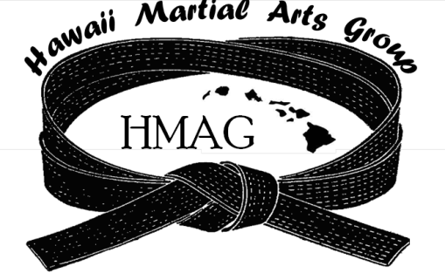
The Hawaii Martial Arts Group
http://www.hawaiimartialartsgroup.com
“Providing Exceptional Competitive Events
With Integrity, Fairness and Fellowship”

6th ANNUAL HAWAII OPEN TOURNAMENT
Manoa Valley District Park - 2721 Kaaipu Ave, Honolulu, Hi 96822
June 13, 2015 – Saturday – 8:30 am to 5:00 pm

Make Checks Payable to: GOJU-KAN HAWAII (payments by mail need to be received by 06/06/15
Send payments to: GOJU-KAN HAWAII, c/o Jann Aki, 44-252 Mikiola Drive, Kaneohe HI, 96744
For more information contact: Sensei Jann Aki (808) 741-3420 / email: theakis1@aol.com

Name: ___________________________________Date of Birth: ____ / ____/ ____ Age: _____
(Month) (Date) (Year)
Address: ____________________________________________ HI _________________
(Street) (State) (Zip Code)
Email: __________________________________________ Cell: _________________________
Instructor: _______________________________ Dojo / Club: ___________________________
KUMITE - $15.00 per event
_____ MALE / _____ FEMALE (check one)
NOVICE (6 mos. or less) 8 – 9 Kyu 6 – 7 Kyu 4 – 5 Kyu Brown Black Belt Open
Ages 6 and under            
Ages 7 – 9                
Ages 10 – 12                
Ages 13 – 15                
Ages 16 – 17                
Ages 18 – 25                 
Ages 26 – 32                
Ages 33 – 40                
Ages 41 – 50                
Ages 51 – 60                
Ages 60 and above                
Tournament Directors reserve the right to combine age divisions

WAIVER AGREEMENT (ALL PARTICIPANTS MUST SIGN)
I, the undersigned, do hereby voluntarily submit my application for attendance and participation in the aforementioned event, and do hereby assume full responsibility for any and all claims, damages, injuries, and/or death against the promoters, City & County of Honolulu, Department of Education, participants and operators of said mentioned Martial Arts event individually or otherwise for any claim for injuries that I may sustain. I also understand that Martial Arts as participated herein, is a body contact sport. ALL PARTICIPANTS WHO HAVE a Heart Condition, High Blood Pressure, Epilepsy, and/or any other illness MUST HAVE HIS/HER PHYSICIAN’S PERMISSION TO PARTICIPATE IN THIS MARTIAL ARTS COMPETION. THE UNDERSIGNED FULLY UNDERSTANDS THAT ANY MEDICAL TREATMENT GIVEN WILL BE OF THE FIRST AID TREATMENT TYPE ONLY.

__________________________________________________________ _______________________________________________________
Signature of Contestant Signature of Consent by Parent or Guardian

IF UNDER THE AGE OF 18 YEARS OLD - THIS RELEASE AND CONSENT MUST BE SIGNED BY A PARENT OR LEGAL GUARDIAN

